

Leics & Rutland NHS Procurement Partnership

Oracle iProc

Non-Catalogue Request Inputting Guide

Accessing Oracle iProcurement

The Oracle Financials Application is available solely via the Intranet and can be accessed via Microsoft Internet Explorer.

Once you have a user name and password you can access the Application via the Internet browser on your PC.

http://patfinapp.lrh-tr.nhs.uk:8001/

Select Apps Logon Links
Then E-Business Home Page

Suggest you put a shortcut on your desktop at this stage

Oracle Home Page

After logging in via the Oracle Application Login screen a list of your
responsibilities is displayed. These will depend on the role that you perform.

Note: If you only have one responsibility you will go straight to that option.

Select LPT iProc User
and then iProcurement Home Page

The Shopping Screen is displayed :

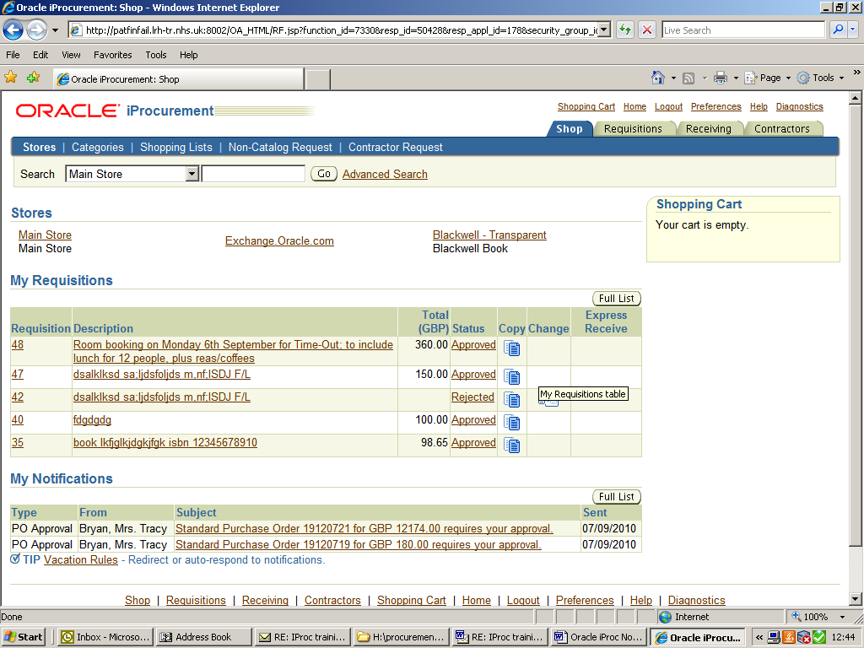

All requisitions at the current time will be non-catalogue requisitions where the Goods or Services you wish to purchase are not available in an online catalogue.
(Online catalogues are not available at the moment but may become available at some time in the future).

‘Non-catalogue request’ on the blue menu bar should be selected.

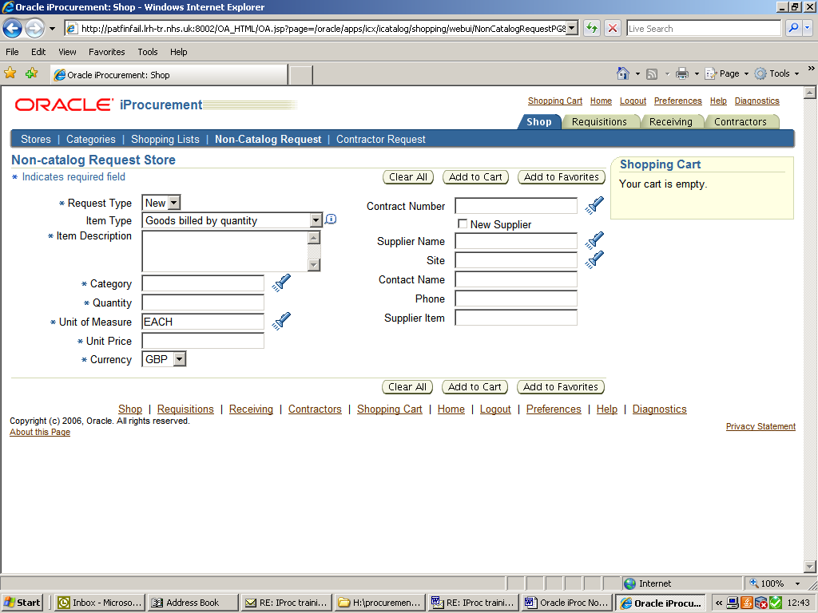

NOTE: Fields marked with * are mandatory.

N.B. Timeout
The Application will timeout after 1 hour and if you are part way through a
requisition, all your information will be lost. Therefore, remember to save your cart if
you are going away from your desk.

Raising a Non-Catalogue Request

Item Type
Select the item type by deciding whether your requisition is for a number of goods at a certain unit price, or if it is for a service where the price is fixed for the whole amount.

Item description
The Item Description must contain full details of the goods/services that you require. Remember to include all details that the supplier will need to ensure that you receive the correct goods/service.
You can also type in any extra information for the supplier (eg delivery contact details)
as long as it will fit in the field.
If you need extra space for your text, you can continue on an Attachment – more information further below.

Selecting the Category

You must next identify the category code to use. The code is linked to the subjective (expense) code, which forms part of the account code combination, and helps to build the Charge Account.
If the code is not entered you will not be able to proceed..
If you know the category code you can type it in the field; if not you will need to identify it from the list of values:

Click on the torch at the side of the Category field;
(there is a quick look-up table of category codes at Appendix i)

Select the ‘Description’ search option, and enter a key word into the box.
E.G using the wildcard ’%’ key – entering %Drinks% will bring up all the categories containing the word ‘Drinks’ – see screenshots below.

Selecting the category code will insert it into the requisition for you.

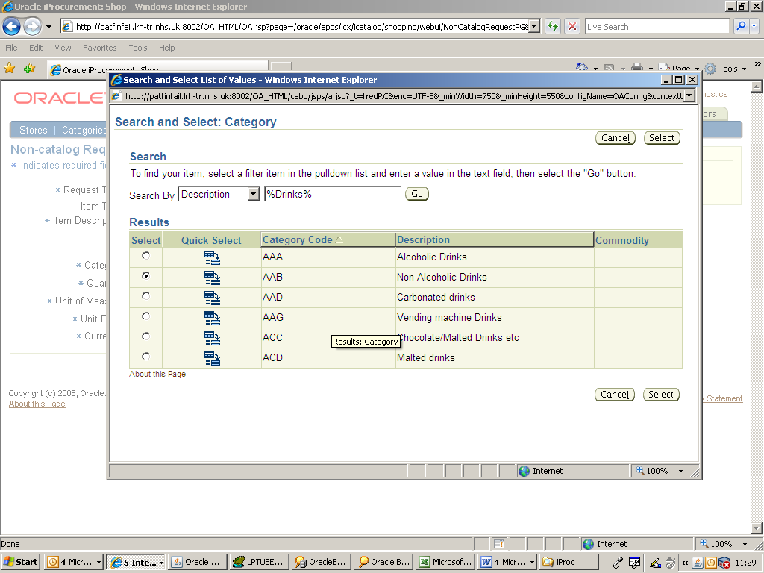

Complete ‘Qty’, ‘Unit of Measure’ and ‘Unit Price’ (excluding vat).
(The Unit of Measure can be selected in the same way but ‘each’ will usually suffice)

Selecting the Supplier:

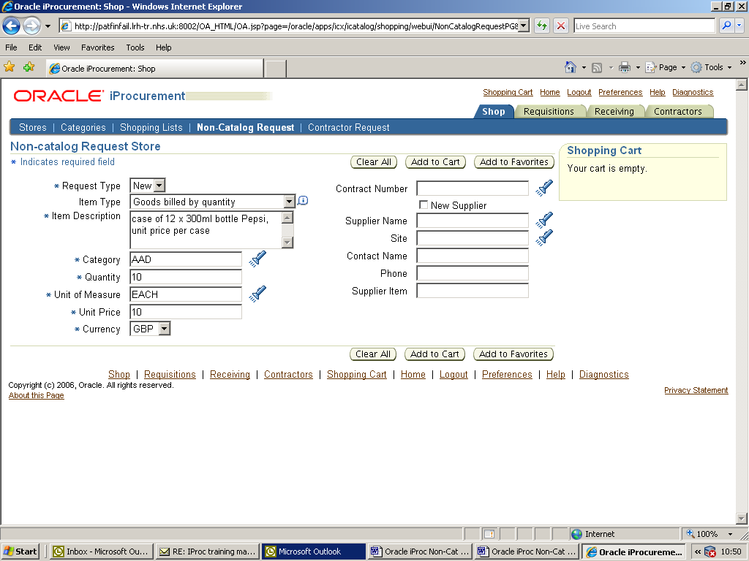

If you know the Supplier Name then type it in or click on the torch and a form will open where you can search the supplier name as follows:

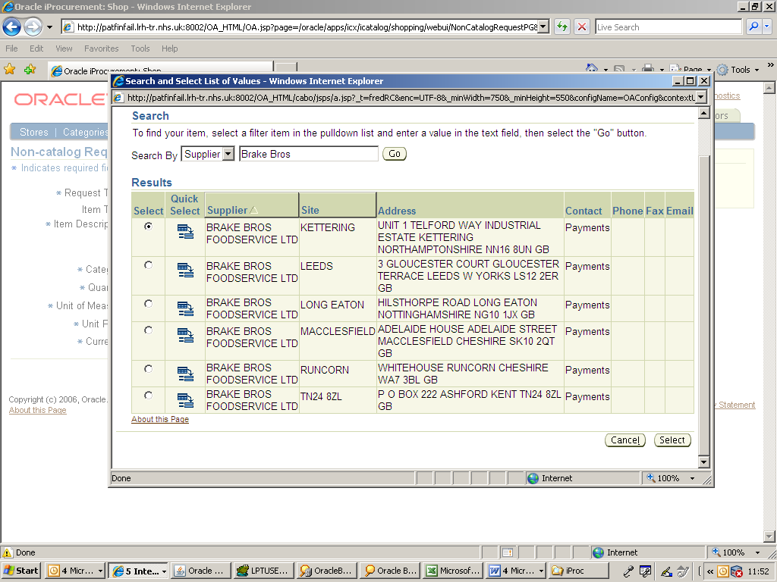

Selecting the chosen supplier will automatically put it into your requisition.
If you cannot identify the supplier you can tick the ‘New Supplier’ box which will allow you to type in the supplier details as free text.

N.B. you will need to make a note in the ‘Note to Buyer’ field at the checkout stage if you are using a supplier that does not already exist in the system (see checkout step 2 below).

At this point your shopping cart will be showing that your cart is empty
Select ‘Add to Cart’ and your requisition line will appear in your shopping cart.

If you do not want to add any more lines you should proceed to View cart and checkout. You can remove requisition lines here by using the ‘dustbin’ delete icon.

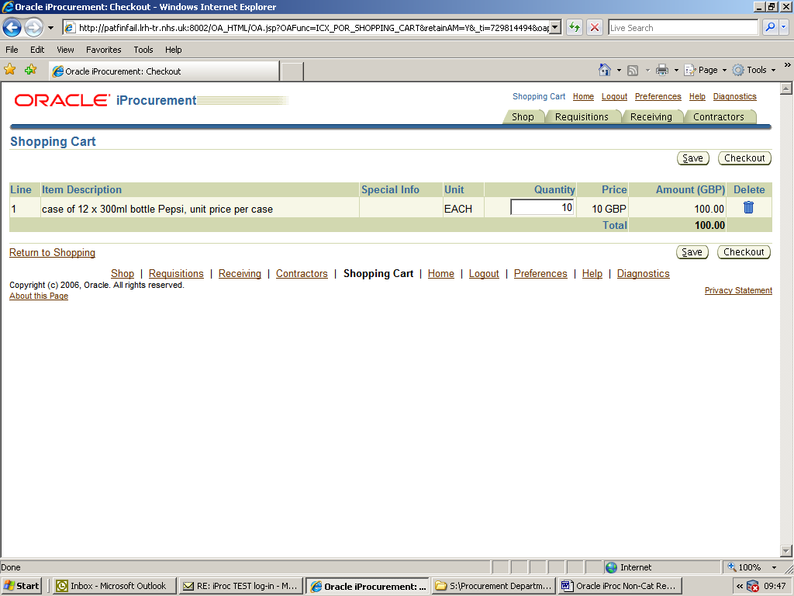

If you need to add further lines to this requisition, click on the Shop tab and then back onto the ‘Non-catalogue request’ option, and repeat as above.

Do not select Save unless you want to save your requisition and come back to it later.

Proceed to checkout.

Checkout

There are three Checkout screens:

1. Requisition Information

The first Checkout screen is Requisition Information, which holds the
Requisition, Delivery and Billing details. In most cases you will accept all of the
default options as these are specified in your profile. However you can override the defaults if you wish.

The Requisition Description automatically pulls the Item Description of the first
item you added to your cart. When ordering a number of items this will not be an appropriate title for the requisition.
You may wish to amend this ‘title’ to one of your own choice which will enable you to retrieve the requisition at a later date.
Click into Requisition Description and give your requisition a suitable name.
NOTE: This name will also be visible to the Approver once submitted for
approval.

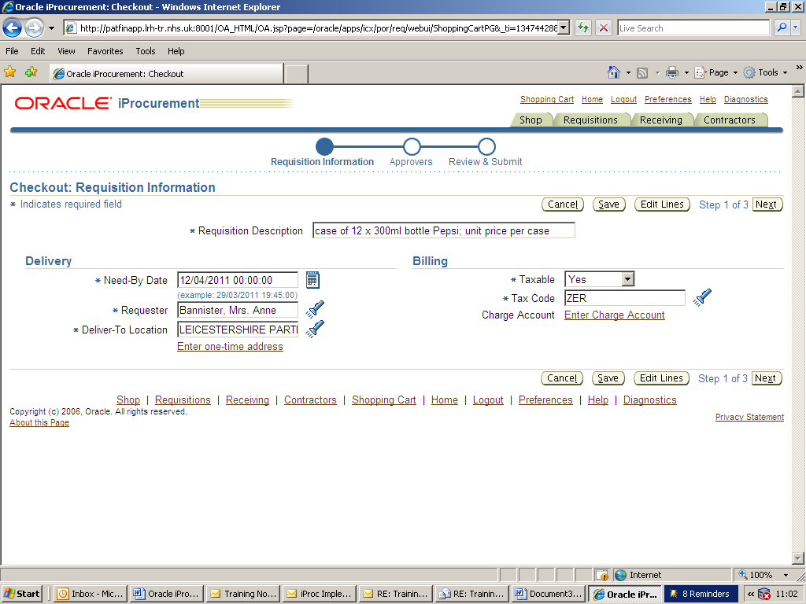

Need by Date – this is the date when you require the goods and the field
will be populated automatically. The date can be overwritten or selected from the calendar at the side of the field.

Requester – this will populate with your name

Deliver to Location - select from the drop-down list by clicking on the torch symbol;
Your delivery location name should start with your 6-digit requisition point code (eg 19****).

Charge Account – click on the ‘enter charge account’ link.

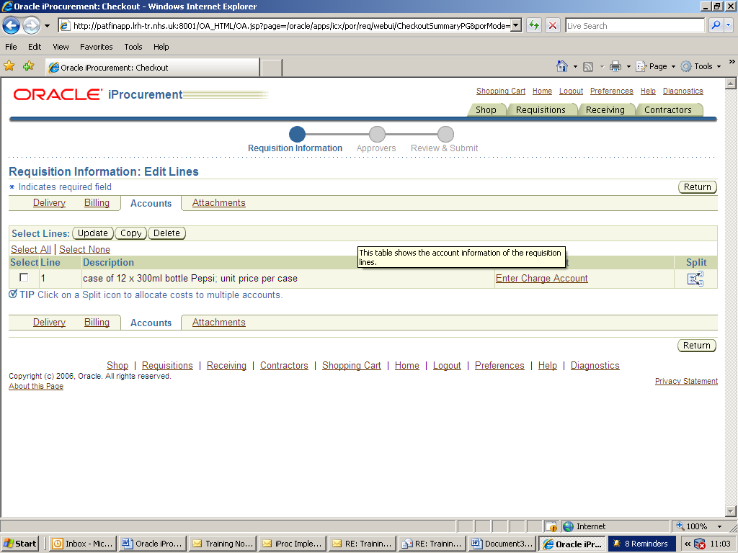

The following screen will be displayed.

If you know your full charge account code, you can type it in here but it must be in the correct format: LE-0340-7196-0000-0000 (example only)

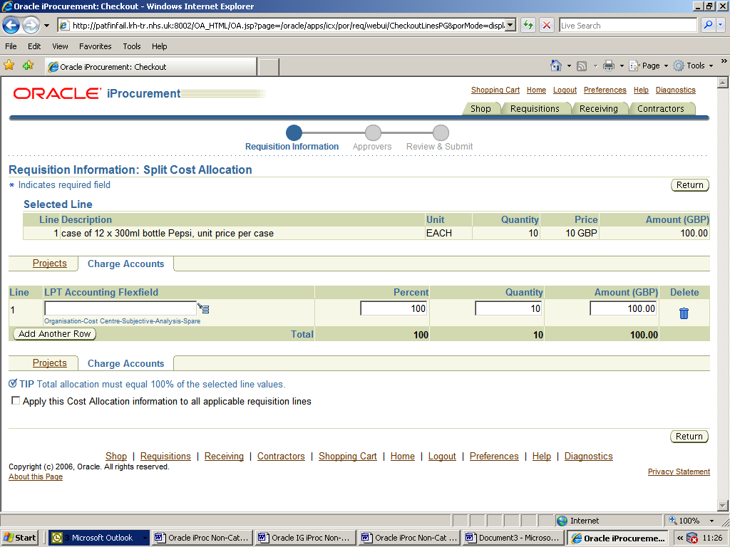

Alternatively, the icon indicated will open up the search option where you can select and check your code combination :

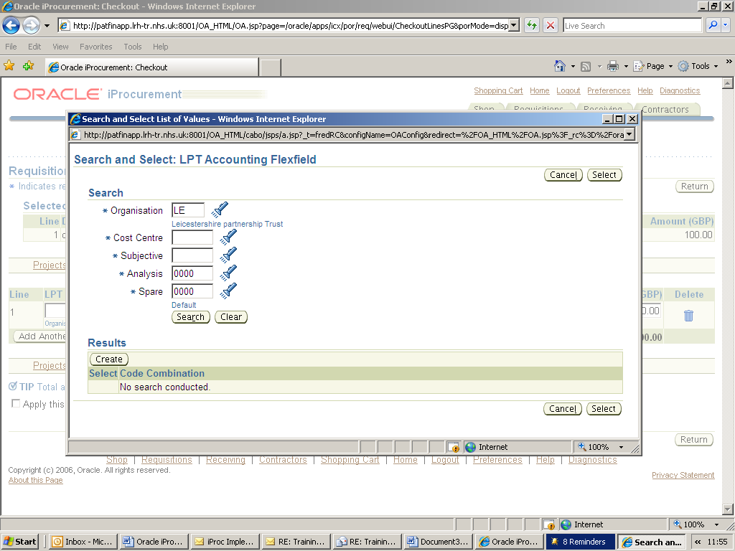

If your code is not recognised, you will need to contact your Finance department with
details of the item(s) you are ordering and your Cost Centre and they will ensure that the code is set up.

NOTE: You will not be able to proceed through the checkout process without this
information.

If all Charge Account information is displayed, click Return until you are back to the checkout screen and select Next .

2. Review Approver List

Check that the approver displayed is correct. The Approver name displayed will be your Line Manager or Supervisor and in most cases you will accept the default Approver that the system allocates.

This screen is also used to add any notes to justify your reason for ordering the goods or services to your approver, and to add notes for the Buyer, (i.e.. any information that you would have written on the blue requisition for Procurement Dept, including information about the supplier name/address).

The notes fields are not mandatory, but are extremely useful to add any additional information that you deem appropriate to avoid any delay with your order.
The Buyer will see the ‘Note to Buyer’ before starting to process the requisition.

Note to Approver Note to Buyer (Procurement)

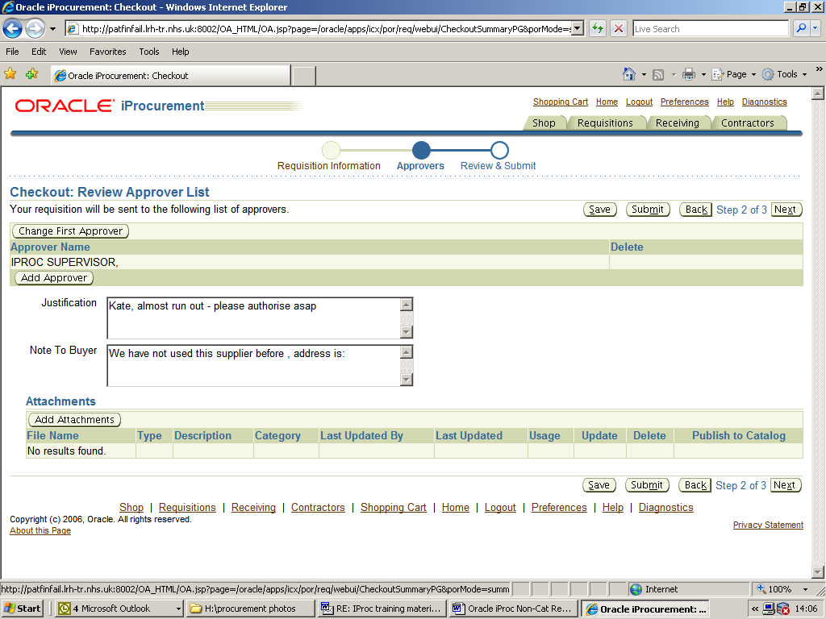

Add attachments

Stored documents
If you have documents that need to be sent to the supplier you can attach them as an electronic file and they will be faxed to the supplier by Procurement staff.
They will remain as an attachment on the requisition.

The ‘Description’ box is a free-text field and is mandatory – you must enter some description of your attachment, however brief.

Text to print on the order
The only attachments that will print out on the order are Text attachments
Select category ‘To Supplier’ from the drop-down options, and highlight the ‘Text’ option, and then enter your required text. This will print out on the purchase order.

If you need to add several attachments, you can name them in the box at the bottom of the screen for identification purposes e.g. ‘delivery information’, ‘quotation’ etc

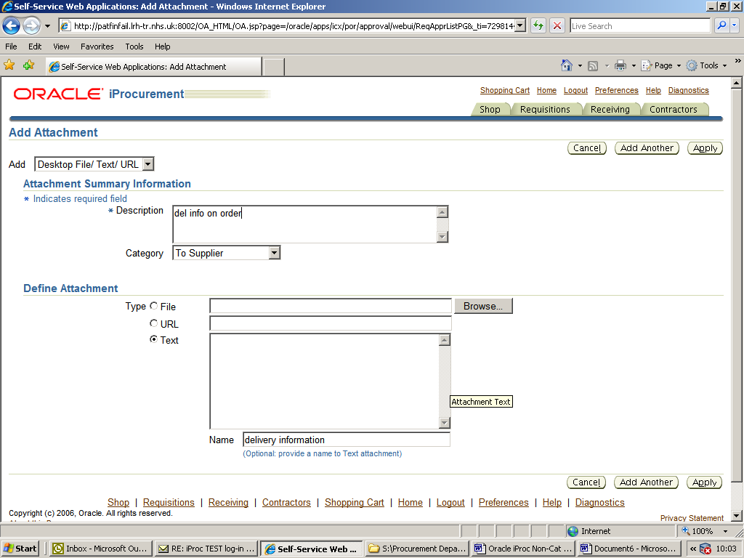

Click ‘Apply’ to return to the step 2 screen.
If all information is correct, click ‘Next’’

3. Review and Submit Requistion

Before submitting your requisition for approval you need to check that all of the
information contained within it is correct. If you have made an error within your requisition it should be picked up by your Approver and the requisition will be rejected. If an error is not noticed, the requisition will be sent out to the supplier and the wrong goods may be supplied.

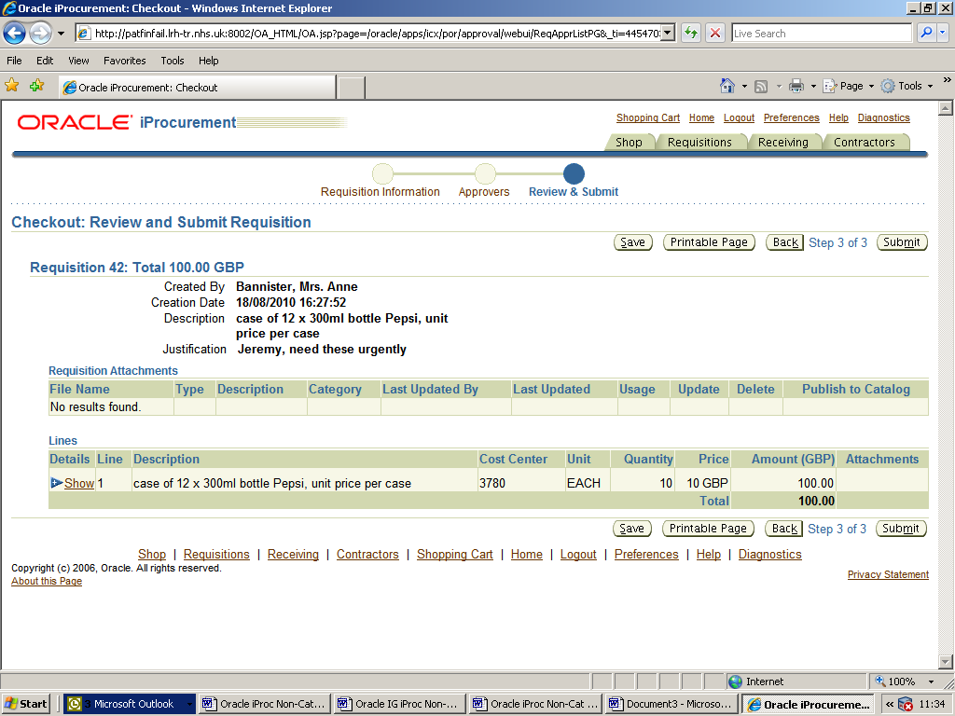

Click Show to see all information for the selected line.
To close the line information, you will see that Show has changed to Hide.
Click Hide to collapse the information.
When you are happy that all the information is correct, click Submit
.

Your confirmation will be displayed and your requisition assigned a unique requisition number.

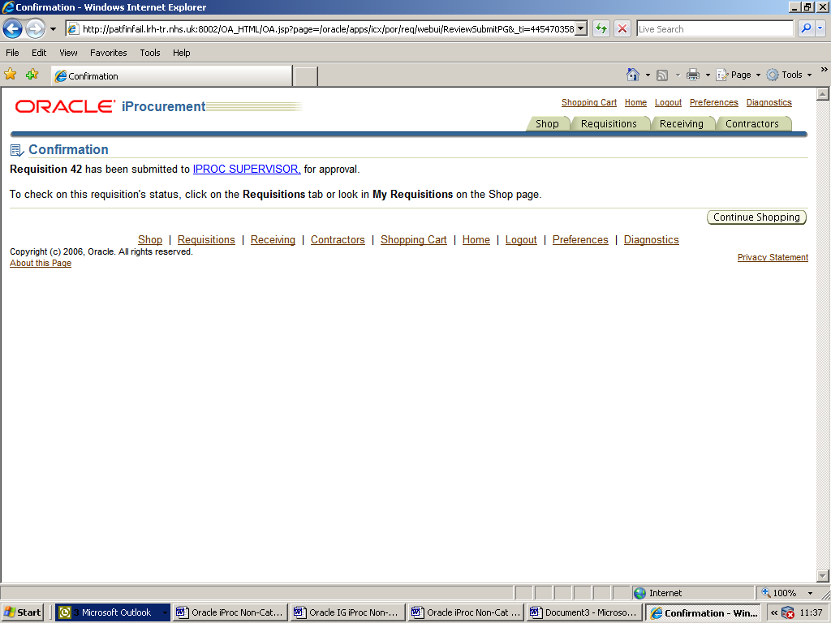

This screen gives you full details of where the requisition can be viewed.

What happens next?
The requisition is forwarded via workflow to the approver(s) notifications list. The
approver(s) will receive an email to tell them they have requisitions to approve.
An email will be sent in a further two days to remind the approver there are
requisitions waiting, and again after another two days,
If the requisition is not approved after 2 more days it will drop out of the approver’s list
and the status of the requisition will change from In-Process to Incomplete.
The requester will receive a notification saying it has not been approved. The
requisition can then either be resubmitted to the original approver or the requester
can change the approver and submit the requisition.

The Approver will receive an email notification asking them to log-in and approve the requisition.
Once approved, a purchase order will be generated by the Procurement team, which in most cases will be autofaxed to the supplier.

Your stored requisition details can be seen by clicking the Requisitions tab, where you can check the progress of your requisition and will be able to view the Purchase Order number when available. This will change to brown when the Purchase Order is fully approved and you will be able to select it and view the detail of the Order.

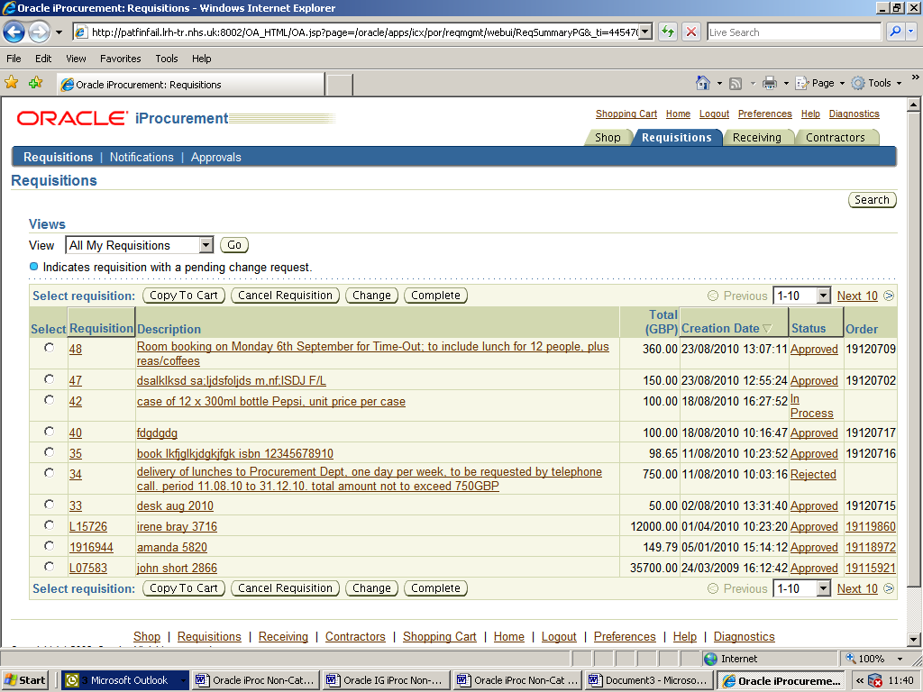

Any text shown coloured brown and underlined will enable you to open up further information.

Once your purchase order is approved, you should be able to see any goods available for Receipting by opening the Receiving tab.

Should you experience any problems with raising a requisition please contact Anne Bannister on 2950441 or Tracy Bryan on 2950442.

Appendix i
Section | Cat Code | ITEM Code Description
A Provisions
 | AAA | Alcoholic Drinks
 | AAB | Non-Alcoholic Drinks
 | AAC | Bottled Water
 | AAG | Vending machine Drinks
 | ABA | Baby Foods
 | ABB | Junior Foods
 | ABC | Baby Milk
 | ABF | Dietary Preparations
 | ACA | Tea/Tea Bags
 | ACB | Coffee
 | ACC | Chocolate/Malted Drinks etc
 | ACH | Vending Machine Ingredients
 | ACU | Speciality Beverages
 | ADA | Biscuits
 | ADB | Bread
 | ADF | Cereals/Pasta/Pulses
 | ADK | Preserves/Spreads
 | ADL | Soups
 | ADN | Sugar
 | ADS | Cakes/Pastries/Baking Mixes
 | ADD | Confectionery/Snacks
 | ADV | Vending Machine Supplies
 | AEA | Butter/Margarine/Oil/Fats
 | AEC | Eggs/Egg Products
 | AED | Milk/Cream/Ice Cream/Yoghurts
 | AEJ | Cheese/Cottage Cheese etc
 | AFA | Meat/Fish (Fresh/Chilled)
 | AFI | Meat/Fish (Processed)
 | AFP | Meat/Fish (Frozen)
 | AFU | Meat/Fish (Canned)
 | AGA | Fruit/Veg (Fresh)
 | AGC | Fruit/Veg (Canned)
 | AGE | Fruit/Veg (Frozen)
 | AGG | Fruit/Veg (Dried)
 | AHA | Prepared Meals
 | AHB | Sandwiches
 | AHC | Sandwich Fillings
 | AIH | Frozen Prepared Meals
 | AIJ | Frozen Desserts
 | AJA | Flavourings/Herbs/Spices/Stuffing etc
 | AKA | Baby Milk
 | AKB | Vitamins/Minerals
 | AZB | Dietetic Food
B Staff Uniform
 | BAY | AHP Uniforms
 | BAZ | Nurses Uniforms
 | BBZ | Corporate Uniforms
 | BCB | General Workwear
 | BCZ | Safety Workwear
 | BDZ | Catering Uniforms
 | BEA | General Uniform Accessories
 | BEE | Headwear
 | BWH | Theatre Footwear
 | BWO | Disposable Theatrewear
 | BXZ | Fabric/Material (Clothing)
 | BYX | Laboratory Clothing
 | BZX | Safety Footwear
 | BZZ | General Footwear
C Patients Clothing
 | CAX | Patients Clothing General
 | CJG | Patients Bedwear General
 | CJK | Dressing Gowns/Examination Gowns
 | CJZ | Patients Bedwear Hire
 | CVX | Patients Footwear
 | CXC | Incontinence Clothing
 | CXP | Incontinence Pads/Pants (Disposable)
D Pharmaceuticals/Blood products/Medical Gases
 | DEV | Dialysis Products
 | DYX | Medical Gases
E Dressings
 | EAA | Misc Casting/Splinting Materials etc
 | EBB | Misc Dressings/Pads/Bandages etc
 | ELY | Misc Wound Management Products
 | ERA | Drills/Drill Accessories
 | ERP | Misc Podiatry Products/Materials
 | ETA | Misc Sterilisation Packaging
 | EVX | Misc Procedure Packs
F Med/Surg Equipment
 | FBE | Endoscopy Equipment & Accessories
 | FBE | Endoscopy Equipment Repair/Maintenance
 | FBF | Electric Medical Equipment (Diagnostic, Endoscopic, ECG, Suction, Re-sus etc)
 | FBF | Electric Lifting Equipment (Hoists) and Accessories
 | FBF | Drugs Fridge
 | FBF | Electric Plinths/Couches
 | FBF | Electric Medical Equipment Accessories
 | FBF | Paper rolls for ECG machines etc
 | FBG | Therapy/Rehab Equipment/Instrumentation
 | FBG | Therapy/Rehab Equipment/Instrumentation Repair/Maintenance
 | FBR | Non-Electric Medical Equipment (Sphygs/Stethoscopes/Peak Flow/Trach Tubes etc)
 | FBR | Hydraulic Lifting Equipment (Hoists) and Accessories
 | FBR | Non-Electric Medical Equipment Accessories
 | FBX | Electric Medical Equipment Maintenance (incl Calibration)
 | FBX | Non-Electric Medical Equipment Maintenance (incl Calibration)
 | FBY | Electric Medical Equipment Repair
 | FBY | Non-Electric Medical Equipment Repair
 | FBZ | Medical/Surgical Equipment Hire
 | FCB | Surgical Instruments Non-Disposable
 | FCC | Surgical Instruments Disposable
 | FDA | Anaesthetic Equipment/Accessories
 | FDX | Anaesthetic Equipment/Accessories Maintenance
 | FDY | Anaesthetic Equipment/Accessories Repairs
 | FQG | Voice Prostheses
 | FXP | Medical Consumables(Gloves/Syringes/Cannullae/Thermometers)
G Patients Appliances
 | GBA | Condoms/Femidoms
 | GBB | IUDs/Coils
 | GCB | Wigs Human Hair/Modacrylic/Synthetic
 | GFB | Hearing Aids/Accessories/Spares
 | GGB | Orthodontic Appliancies/Sundries
 | GKB | Orthotic Products General
 | GKK | Surgical Hosiery
 | GKX | Orthotic Products Maintenance
 | GKY | Orthotic Products Repair
 | GLA | Breast Prostheses etc
 | GPB | General Appliances (inc alarms etc)
 | GPC | Stomacare Products
 | GSB | Environmental Aids/Equipment/Accessories
 | GTB | Home Management/Daily Living Aids
 | GVF | Walking Aids, Frames/Sticks/Crutches etc
 | GWB | Wheelchairs, Accessories, Spares
H Chemicals/Reagents
 | HBB | Analytical Kits/Culture Media/Re-agents etc
 | HXB | Misc Chemicals/Reagents
I Dental/Optical Equipment
 | IBB | Dental Surgery Equipment Purchase
 | IBX | Dental Surgery Equipment Repair/Maintenance
 | ICB | Dental Surgery Instruments Purchase
 | ICX | Dental Surgery Instruments Repair/Maintenance
 | IKB | Dental Surgery Sundries inc adhesives, bottles, brushes
 | IRB | Dental Laboratory Items Purchase
 | IRX | Dental Laboratory Items Repair/Maintenance
 | ITX | Dental Equipment Hire
 | IVA | Ophthalmic Surgery Equipment Purchase
 | IVB | Optical Equipment Sundries
 | IVC | Ophthalmic Instruments Purchase
 | IVE | Cataract Lenses
 | IVX | Ophthalmic/Optical Equipment Repair/Maintenance
 | IWM | Radioactive Indicators/Tracers
J Diagnostic Imaging/Radiotherapy Equipment and Services
 | JAA | X-Ray Equipment
 | JAB | Ultrasound Equipment
 | JAC | MRI Equipment
 | JAD | CT/CAT Equipment
 | JAE | Breast Screening/Mammography Equipment
 | JAF | PACS Services
 | JAX | Imaging Equipment Maintenance
 | JAY | Imaging Equipment Repair
 | JJB | X-Ray Film Processors Equipment and Sundries
 | JJF | Silver recovery Units
 | JJK | X-Ray film viewers
 | JJX | X-Ray Film Processors and Silver Recovery Units Maintenance
 | JJY | X-Ray Film Processors and Silver Recovery Units Repair
 | JLB | Film Duplicating and Laser Imaging Equipment (Tomography, Xerographic Imaging etc)
 | JLX | Film Duplicating and Laser Imaging Equipment Repair/Maintenance
 | JMB | Radiotherapy Equipment and Sundries
 | JMX | Radiotherapy Equipment Maintenance
 | JMY | Radiotherapy Equipment Repair
 | JTB | X-Ray Imaging Film
 | JTF | X-Ray Ultrasound Film
 | JTL | X-Ray Paper
 | JTL | X Ray Sundries, Stickers & Labels
 | JVB | X-Ray Film Processing Chemicals
 | JZB | Photographic Equipment
 | JZP | Photographic Services
 | JZX | Photographic Equipment Maintenance
 | JZY | Photographic Equipment Repair
 | JZZ | Photographic Equipment Hire
K Laboratory Equipment/Services
 | KBB | Laboratory Equipment
 | KBD | Laboratory Bottles/Containers/Caps
 | KBX | Laboratory Equipment Maintenance
 | KBY | Laboratory Equipment Repair
 | KDU | Laboratory Furniture
 | KFB | Analysers
 | KFC | Blood Gas Machines
L Fuel
 | LAF | Gas Mains/Meters
 | LAK | Fuel/Diesel Oil/Boiler Fuel
M Hotel Services Equipment/Materials/Services
 | MBB | Refrigeration/Water Coolers
 | MBK | Cookers/Ovens/Hobs/Fryers/Grills etc
 | MBM | Servery Storage
 | MBN | Vending Machines
 | MBP | Food preparation Equipment
 | MBP | Rental Food preparation Equipment
 | MBS | Small Appliances
 | MBX | Catering Equipment Maintenance
 | MBY | Catering Equipment Repair
 | MCB | Rental Refrigeration/Water Coolers
 | MCK | Rental Cookers/Ovens/Hobs/Fryers/Grills etc
 | MCM | Rental Servery Storage
 | MCN | Rental Vending Machines
 | MCS | Rental Small Appliances
 | MFB | Decontamination Equipment
 | MFD | Sterilisers/Autoclaves/Disinfectors
 | MFD | Sterilisers/Autoclaves/Disinfectors Repair/Maintenance
 | MFF | High Pressure Cleaning Equipment
 | MFL | Specialist Cleaning Equipment
 | MFX | Specialist Cleaning Equipment Maintenance
 | MFY | Specialist Cleaning Equipment Repair
 | MGM | Floor Cleaning Equipment
 | MGM | Floor Cleaning Equipment Consumables
 | MGX | Floor Cleaning Equipment Maintenance
 | MGY | Floor Cleaning Equipment Repair
 | MKB | Small Equipment, Brushes/Dustpans/Cloths/Mops etc
 | MKJ | Cleaning Products, BlEAes/Disinfectants/etc
 | MKK | Dishwasher Products
 | MLL | Tumble Dryers
 | MLM | Washing Machines
 | MLX | Laundry Equipment Maintenance
 | MLY | Laundry Equipment Repair
 | MPB | Sanitary Ware, Baths/W.C.s etc
 | MPH | Incinerators/Disposal Units
 | MPH | Incinerators/Disposal Units Repair/Maintenance
 | MPH | Incinerators/Disposal Units Hire/Rental
 | MPX | Sanitary Equipment Maintenance
 | MPY | Sanitary Equipment Repair
 | MQA | Alarms/Installations/Inspection
 | MQB | Blankets/ Buckets/Hoses/Reels/Sprinklers
 | MQE | Extinguishers/Fire Pump Call Out & Service
 | MQK | Stand Pipes/Hydrant Services Riser Maintenance/Inspection
 | MQP | Fire Escapes/Fire Doors & Inspections
 | MTB | Toiletries/Personal Hygiene Products
 | MVB | Paper Bags/Sacks
 | MVF | Plastic Bags/Sacks
 | MVG | Tie Tags
 | MWB | Toilet Paper
 | MWJ | secretary
 | MWK | Paper/Linen Hand Towels/Individual Rolls
 | MXA | Contract Catering Services
 | MXB | Contract Pest Control Services
 | MXC | Contract Cleaning Services Buildings Equipment
 | MXD | Contract Cleaning Services Window cleaning
 | MXE | Collection Services for Recyclable Materials
 | MXJ | Hygiene Sanitary Services
 | MXK | Catering Waste Disposal Services
 | MXM | Contract Laundry Services
 | MXN | Contract Total Linen Service
 | MXO | Contract Security Services
 | MXP | Contract Portering Messenger Services
 | MXQ | Contract Cytoxic Waste
 | MXR | Refuse Disposal Clinical
 | MXS | Refuse Disposal Confidential
 | MXT | Refuse Disposal General
P Building/Engineering Products/Services (Estates)
 | PFB | Ironmongery, Sundries
 | PHB | Heating/Ventilation Boilers/Equipment
 | PHX | Heating/Ventilation Boilers/Equipment Maintenance
 | PHY | Heating/Ventilation Boilers/Equipment Repair
 | PMP | General Electrical Equipment/Sundries
 | PMS | Security Equipment
 | PMS | Security Equipment Repair/Maintenance
 | PMT | Testing Equipment
 | PMX | Electrical Equipment Maintenance
 | PMY | Electrical Equipment Repair
 | PTC | Building Materials (inc. Timber)
 | PTL | Tools/Equipment
 | PTT | Plant Equipment (Signage)
 | PTW | Mobile Buildings
 | PTX | Tools/Equipment Maintenance
 | PTY | Tools/Equipment Repair
 | PTZ | Tools/Equipment Hire
 | PWB | Rents/Rates
 | PZA | Lift/ Automatic Door Maintenance etc
 | PZB | Painting/Decorating Services
 | PZC | Building Contracts
 | PZD | Supply/Fix Contracts, Minor Works
 | PZF | Grounds/Road Maintenance (Rock Salt)
 | PZM | Non-Structural Building Repairs
 | PZN | Architect/Planning Services
 | PZP | Estates Services
 | PZP | Asbestos survey/removal works
 | PZP | Water/Legionella surveys/works
 | PZQ | Valuers/Surveyor Services
 | PZR | Contract Consultants
S Gardening/Farming
 | SBG | Gardening Equipment
 | SBX | Gardening Equipment Maintenance
 | SBY | Gardening Equipment Repair
 | SFB | Fertilisers/Soil Additives etc
 | SKB | Fungicides/Insecticides etc
 | SQG | Products/Consumables e.g. Pots, Labels, Fencing
 | SQP | Garden Furniture/Ornaments
 | SRB | Plants/Seeds/Shrubs etc
 | SZV | Contract Gardening Services
T Furniture/Fittings
 | TBC | Carpets/Carpet Tiles
 | TBE | Hard Flooring (Vinyl)
 | TBT | Contract Fitting Service
 | TCB | Shelves/Cabinets/Lockers/Rails etc
 | TDB | Bins/Buckets
 | TDQ | Panels/Screens
 | TDS | Showcases/Stands
 | TDT | Trolleys
 | TDU | Cabinets/Mobile Easels/Drawer Units
 | TDZ | Hire Mobile Items
 | TES | Storage units/Racking/Crates etc
 | TFB | Blinds
 | TFF | Curtains/Curtain Fabric/Fitting
 | TFK | Cushions/Other Soft Furnishings
 | TGL | Steps/Step Ladders
 | TGU | Other Household Items
 | THE | Fully upholstered chairs/settees
 | THM | Other chairs
 | THN | Office chairs
 | THQ | Stools
 | THS | Special Seating
 | THT | Re-upholstery Materials/Service
 | THZ | Seating Hire
 | TJC | Table, Office/Meeting
 | TJD | Table, Dining/coffee/occasional
 | TJZ | Table, Hire
 | TKB | Cupboard, Broom/Cleaning/Tool
 | TKS | Cupboard, Stationary/Storage
 | TLB | Bed, Hospital/Divan/Headboards/Accessories
 | TLC | Bed, Specialist Medical/Profiling
 | TLJ | Bed Commmunity
 | TLM | Cots
 | TLP | Mattresses
 | TLX | Specialist Bed Repair/Maintenance
 | TLY | Mattress/Specialist Bed Hire
 | TPU | Furniture Bedroom
 | TQU | Small Furniture Items Lamps/Pictures/Footstools etc
 | TRP | Bathroom Furniture
 | TSS | Personal Weighing Machines/Apparatus
 | TSU | Medical Workstations/Drug Cabinets/Steps etc
 | TUD | Filing Cabinets
 | TUE | Office Furniture, Desking/Workstations/Bookcases
 | TUM | Office Furniture, Loose equipment/Sundries
 | TVK | Kitchen Units
 | TVU | Light Kitchen Furniture
 | TWB | Decorations
 | TWG | TVs/HIFIs etc
 | TWM | Musical Instruments
 | TWM | Musical Instruments Hire/Rental
 | TWS | Recreational Furniture- Snooker/Pool/Table Tennis etc
 | TXB | Church/Chapel Furniture/Fittings
 | TYY | Furniture Fittings Repair/Maintenance
U Hardware/Crockery
 | UFB | Light Kitchen Equipment/Tools/Containers/Sundries
 | UTB | Consumables/Disposables
V Bedding/Linen/Textiles
 | VAJ | Disposable Bed Linen
 | VCB | Disposable Table Linen
 | VEB | Disposable Theatre Drapes
 | VEP | Disposable Tissues/Wipes
 | VHK | Duvets/Quilts/Covers
 | VHM | Sheets/Pillowslips/Blankets
 | VJC | Non-Disposable Linen General
 | VRG | Mattress Covers
 | VRL | Pillows
 | VRM | Mattress Overlays
 | VTU | Textiles/Materials
 | VWB | Haberdashery/Equipment
W Office Equipment/Stationery/Computers/Telecomms
 | WAH | Networks/Comms/Cabling
 | WAJ | Hardware/Add-ons/Upgrades
 | WAP | Computer Consumables
 | WAP | Toner Cartridges various
 | WAR | Computer Software/Licenses
 | WCB | Office Equipment/Machinery (Dictation/Fans/Labelling/Binding/Audio-Visual etc)
 | WCH | Photocopiers - Purchase
 | WCX | Office Equipment/Photocopiers, Maintenance
 | WCY | Office Equipment/Photocopiers, Repairs
 | WCZ | Office Equipment Hire
 | WCZ | Photocopiers - Rental/Copy Charges
 | WFB | Telephones/Fax Machines/Pagers
 | WFE | Line Rental
 | WFM | Switchboard Systems
 | WFR | Sockets/Cabling/Trunking
 | WFX | Telephones/Fax Machines/Pagers Maintenance
 | WFY | Telephones/Fax Machines/Pagers Repairs
 | WJB | Books/Publications/Posters
 | WJF | Pre-recorded Audio/Video
 | WJJ | Maps/Plans
 | WKA | Files/Binders storage
 | WKB | Calendars/Diaries/Planners etc
 | WKC | Desktop Sundries
 | WKD | Mailing/Post Room/Packing
 | WKF | Presentation/Conference
 | WPA | Paper
 | WPB | Labels
 | WPC | Envelopes
 | WPD | Pads
 | WPH | Printed Stationery
 | WPI | Trust Reports
 | WRU | NHS Forms
 | WRU | Info booklets
 | WRU | Record Cards
X Transportation
 | XAF | Vehicle Purchase
 | XAY | Vehicle Repairs
 | XBB | Vehicle Lease
 | XCB | Vehicle Hire
 | XCY | Taxi Services
 | XDE | Passenger Transport Services
 | XDF | Courier Service
Y Recreational/OT Equipment/Souvenirs
 | YAZ | Souvenirs/Items for Retail
 | YSS | Toys/Games/Sports Equipment
 | YTB | Creche Equipment/Learning Aids
 | YUA | Occupational/Industrial Therapy Equipment
 | YUX | Occupational/Industrial Therapy Equipment Maintenance
 | YUA | Occupational/Industrial Therapy Equipment Consumables
 | YUY | Occupational/Industrial Therapy Equipment Repair
Z Staff/Patient Consulting Services/Expenses
 | ZAB | Entertainment/Holidays/Transport/Hairdressing etc
 | ZAB | Healthcare Services from Voluntary Sector
 | ZAC | Performing Rights
 | ZAF | Hairdressing Beauty Therapy
 | ZAG | Library Expenses
 | ZAK | Patient Transport Holidays
 | ZAP | Funeral Services
 | ZCP | Security Cards
 | ZCJ | Staff legal Services General
 | ZCK | Staff Relocation Services
 | ZLB | Medical Staff
 | ZLC | Dental Staff
 | ZLD | Nursing Staff
 | ZLE | Professions Allied to Medicine
 | ZLF | Ambulance Staff
 | ZLG | Speech Therapists
 | ZLH | Scientists
 | ZLI | Chaplains
 | ZLJ | Healthcare Assistants
 | ZLK | MLSOs
 | ZLM | Works Staff
 | ZLO | Pharmacists
 | ZLP | Optical Staff
 | ZLS | Admin/Clerical Staff
 | ZLU | Ancillary Staff
 | ZLV | Maintenance Staff
 | ZMB | Management Consultancy Competition Purchasing Procurement
 | ZMC | Management Consultancy Finance Accounting payroll Payments
 | ZMD | Management Consultancy Information Technology
 | ZME | Management Consultancy Personnel Manpower
 | ZMF | Management Consultancy Management
 | ZMP | Contract Staffing Competition Purchasing Procurement
 | ZMQ | Contract Staffing Finance Accounting Payroll Payments
 | ZMR | Contract Staffing Information Technology
 | ZMS | Contract Staffing Personnel Manpower
 | ZMT | Contract Staffing Management
 | ZOA | Healthcare Services from Independent Sector
 | ZOC | Healthcare Services from Commercial Sector
 | ZOD | Healthcare Services from Other Public Sector)
 | ZOE | Contractual Clinical Services
 | ZOF | Nursing Homes Services
 | ZPA | Non-Healthcare Services from NHS Trusts
 | ZPB | Non-Healthcare Services from PCTs
 | ZPC | Non-Healthcare Services from HAS
 | ZPD | Non-Healthcare Services from Other NHS Bodies
 | ZXA | Recruitment Agency Fees
 | ZWB | Purchasing Procurement Services NHS
 | ZWC | Collection Delivery Distribution Services
 | ZWD | Storage Services
 | ZWE | Finance Accounting Payroll Payment Services
 | ZWF | Debt Collection Services
 | ZWG | Personnel Manpower Services
 | ZWH | Recruitment Advertising Services
 | ZWI | Publicity Services
 | ZWJ | Presscutting servicies
 | ZWK | Estate Management Services
 | ZWL | Conference Exhibition Services
 | ZWM | Training Education Services
 | ZWN | Copying Services General Reprographics
 | ZWO | Printing Publishing Services
 | ZWP | Design Costs
 | ZWR | Record Filming Storage Retrieval Services
 | ZWS | Legal Services Non Staff Related
 | ZWT | Data Analysis services
 | ZWU | Insurance Services
 | ZWV | Interpreting Translation Services
 | ZWW | Preparation Dispatch of Forms
 | ZWY | Research Services
 | ZWZ | Services from Local Authorities
 | ZXA | Advertising General
 | ZXB | Lecture Fees
 | ZXC | Course Fees
 | ZXD | Conference Fees
 | ZXE | Purchase Subscriptions Newspapers Magazines
 | ZXF | Purchase Subscriptions Journals Periodicals Electronic Journals Databases
 | ZXG | Ancillary Ward Support Services
 | ZXH | Audio Visual services
 | ZXI | Radio Services
 | ZXJ | Library Services
 | ZXK | Courier Services
 | ZXL | Cash in Transit Services
 | ZXM | Silver Recovery Services Not Income
 | ZXN | Disposal of Surplus Equipment Services Not Income
 | ZXO | Hire of Rooms Halls Buildings
 | ZXQ | Removal Services Not Staff Relocation
 | ZXS | Travel Services
 | ZXT | Welfare Services
 | ZXU | Health Promotion Activities
 | ZXV | Medical Social Surveys
 | ZYA | Training Materials
 | ZYB | Patent Costs
 | ZYC | Information Technology Security Costs
 | ZYD | External Data Contracts
 | ZYE | FM Computer Contracts
 | ZYF | Audit Fees Statutory
 | ZYG | Audit Fees Internal
 | ZYH | Audit Fees External Non Statutory
 | ZZZ | Miscellaneous

